11/25/2025
TEAM 4
GABRIEL ROSAS, KYAN HAMILTON, BENJAMIN HAASE
<EXSTRUCTA> SYSTEM REQUIREMENTS DOCUMENT
DRAFT

Table of Contents
Introduction 2
Description Model 2
Class Diagram 4
Use Case Diagram 4
Use Case Scenarios 4
System Sequence Charts 4

Introduction
The purpose of this document is to organize the Exstructa project requirements into a single, structured source. It includes key elements such as the project scope, objectives, and development schedule for Exstructa, created by Team Legion. This document ensures that all stakeholders share a clear understanding of what the system must deliver and how its success will be measured.
Exstructa aims to simplify workplace collaboration by unifying core communication features into one platform. The application will provide tools for direct messaging, event planning, and contact list, eliminating the need for multiple separate applications. By centralizing these functions, Exstructa enhances workflow efficiency while reducing costs associated with maintaining several software services.
This introduction establishes the context and purpose of the requirements that follow, guiding the design, development, and validation of the Exstructa system. By consolidating essential communication functions that are typically spread across separate applications, the system will focus on providing a seamless, accessible, and efficient user experience for workplace teams.

Description Model

- Servers - Much like Discord and Slack, Exstructa will have different servers which will include both text and voice channels. The owner(person who created the server) of the server will be able to add whoever they want. Text channels and voice channels are able to be seen by everybody but not everybody can use them depending on their permissions. Servers will have the ability to have other applications added to it like in Slack. Moderators of the servers along with automatic and manual moderation by Exstructa assets will be used.
  - Input - Owner provides information when creating or managing a server. Name, channel names, user id, chat messages
  - Output - Server information, member information, Channel feed
  - Processes -
  - Performance - Depends on the users internet connection to internet and Exstructa servers.
  - Security - Server moderators are to be determined by the owner of the server. Server moderators will be able to silence, block, and ban content and users at their own discretion. Exstructa moderators will also be active in making sure security is upheld.

- Server Roles - Owners will also be able to create roles allowing them to set permissions for their users and to organize their server to maintain order. In these servers there will also be a list member and their roles allowing you to see who is in the server and who is currently online
  - Input - Owner creates and names a role, inputs role settings, saves role settings, and assigns roles to certain members.
  - Output - Members can be renamed to that role and have the abilities assigned to that role.
  - Processes -
  - Performance -
  - Security - Only the owner is allowed to access role management and has the authority to change any of the settings.

- Direct Messaging - This is meant to be like E-mail since it is a more formal environment. It will look like Google direct messaging in Gmail. In Exstructa you can either choose a contact or input someone's email to start a direct message. You can also add other people to that direct message to make it a group chat. Block
  - Input - User must input a contact or another user’s email to begin a direct message. Privacy and security preferences for contacts will be provided by the user.
  - Output - User can message each other and start individual voice calls
  - Processes -
  - Performance -
  - Security - Users have the ability to block unwanted contacts and they can also report those unwanted contacts to Exstructa staff.

- Shared Calendar -This feature is a server-wide calendar. It has events and dates important to the server to help in the organization of work. The calendar is not only for server-wide events, though, since individual people and channel-wide events can also be added and will be seen only to those with permissions to do so.
  - Input -
  - Output -
  - Processes -
  - Performance
  - Security -

- Contact - Our app will include a list of contacts which consist of saved users and recipients. This list updates when a message, email or meeting is sent to another user. The send feature allows you to send an email to multiple people at once by entering the names of the contact list. To create a “New contact list," enter a name and description, and then add individual contacts by typing their names and email addresses.
  - Input -
  - Output -
  - Processes -
  - Performance -
  - Security -

Class Diagram
Create a class diagram. The Class Diagram should contain all of the system objects, their attributes, and any known methods. This diagram may be included as a separate file – it does not need to be inserted into this Word document.

Use Case Diagram
Create a Use Case Diagram for all of the "uses" of your system. This diagram may be included as a separate file – it does not need to be inserted into this Word document.
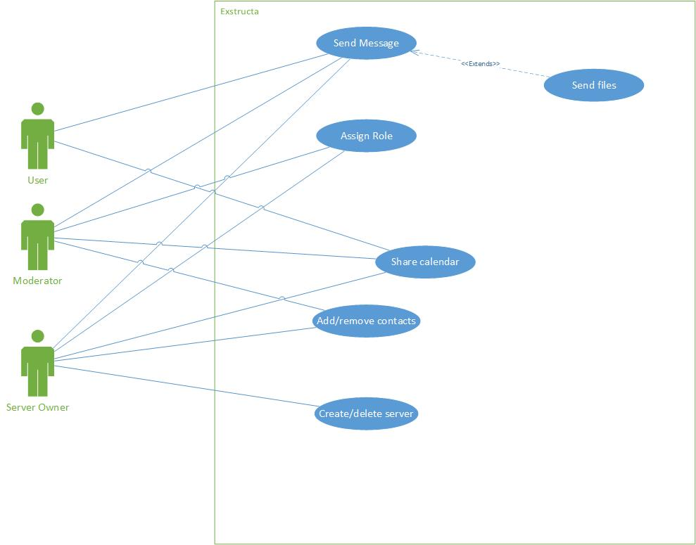

Use Case Scenarios
Create a full description Use Case Scenario (detailed descriptions) for each use case of the system. This full scenario should include an enumerated list of steps involved in the activity as well as any exception conditions.

System Sequence Charts
For each Use Case Scenario, provide a sequence diagram. Use your class diagram, use case diagram and scenarios to create the corresponding System Sequence Diagram.

